[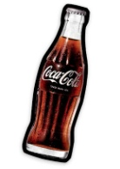](http://www.google.es/url?sa=i&rct=j&q=&esrc=s&frm=1&source=images&cd=&cad=rja&docid=v9FBnji9GqzdXM&tbnid=yMueN_0-RgPswM:&ved=0CAUQjRw&url=http://elregaloriginal.blogspot.com/2012/07/cojin-botella-de-coca-cola.html&ei=DolFUuuUJOSA0AXBgoCACw&bvm=bv.53217764,d.ZGU&psig=AFQjCNELAHfupzCCcTIQ3SXBhUXuNG-VvQ&ust=1380375171859221)[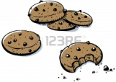](http://www.google.es/url?sa=i&rct=j&q=&esrc=s&frm=1&source=images&cd=&cad=rja&docid=7kQASUFYaJrGzM&tbnid=bxAaI7rA3hsQ6M:&ved=0CAUQjRw&url=http://es.123rf.com/photo_17780594_una-pequena-pila-de-dibujos-animados-galletas-con-chispas-de-chocolate.html&ei=ropFUr62HqW60wWm5oBo&bvm=bv.53217764,d.ZGU&psig=AFQjCNFmD59Xdh0N2mC8MBHZcfB3h8A_pw&ust=1380375563250965)[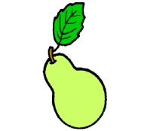](http://www.google.es/url?sa=i&rct=j&q=&esrc=s&frm=1&source=images&cd=&cad=rja&docid=355-70m_E336sM&tbnid=GLmZx0C911MXkM:&ved=0CAUQjRw&url=http://galeria.dibujos.net/comida/frutas/pera-pintado-por-p1a2-9776994.html&ei=hpVFUvL8IYKW0AXjo4HwDQ&psig=AFQjCNFXzSs58goqBoYhBFD-gmxn5UHMig&ust=1380378364202555)[](http://www.google.es/url?sa=i&rct=j&q=&esrc=s&frm=1&source=images&cd=&cad=rja&docid=FOh66npW-XbsIM&tbnid=uRkEePpq1JaSnM:&ved=0CAUQjRw&url=http://fabricadebestsellers.megustaescribir.com/&ei=aodFUu2lNbPI0AWVjID4Bw&bvm=bv.53217764,d.ZGU&psig=AFQjCNEqfwbH8LmhZWLJbrFwMIK3nGYrVA&ust=1380374756124209)[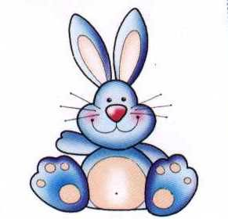](http://www.google.es/url?sa=i&rct=j&q=&esrc=s&frm=1&source=images&cd=&cad=rja&docid=P8gkTcVJVzyI8M&tbnid=ukzcQLDfckallM:&ved=0CAUQjRw&url=http://www.imagui.com/a/conejos-tiernos-dibujo-i6ep7zXM7&ei=Q41FUuGJIcTL0QXi24C4Dw&psig=AFQjCNH24JIsni8lXZ3h_OYebO5b9-GrkA&ust=1380376231814277)[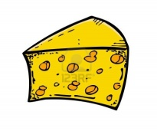](http://www.google.es/url?sa=i&rct=j&q=&esrc=s&frm=1&source=images&cd=&cad=rja&docid=s09-lLRMCLBwJM&tbnid=v54QIaKFIkoucM:&ved=0CAUQjRw&url=http://es.123rf.com/photo_13764345_de-queso-al-estilo-dibujo.html&ei=zIlFUpLAKqbL0AWI24DoBQ&bvm=bv.53217764,d.ZGU&psig=AFQjCNFrjF4kMdj7KuBWlv6NxmZ1sCGVmg&ust=1380375307499982)[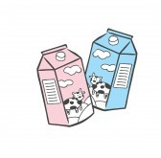](http://www.google.es/url?sa=i&rct=j&q=&esrc=s&frm=1&source=images&cd=&cad=rja&docid=HVaqPG1NypERtM&tbnid=lNkAVT4Ov5IUEM:&ved=0CAUQjRw&url=http://www.123rf.com/clipart-vector/strawberry_yogurt.html&ei=cYxFUuikMKK20wWSi4DIBQ&bvm=bv.53217764,d.Yms&psig=AFQjCNFJUdKxm1MOiiCy_JYabAaesNY9yA&ust=1380376013208160) [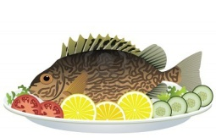](http://www.google.es/url?sa=i&source=images&cd=&cad=rja&docid=EHAL0slgoHJzsM&tbnid=u7I1T80NVaYXVM:&ved=&url=http://pinake.wordpress.com/page/21/&ei=SYtFUr73JO_07Aa8roDoBQ&psig=AFQjCNFcJ4n_Cee6SB6wluLllu-Yk_4n9Q&ust=1380375753659398)[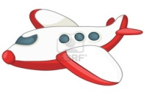](http://www.google.es/url?sa=i&rct=j&q=&esrc=s&frm=1&source=images&cd=&cad=rja&docid=Se1ioXgID31dOM&tbnid=A7mQBsw4QpkcHM:&ved=0CAUQjRw&url=http://es.123rf.com/photo_12043683_avion-de-dibujos-animados.html&ei=DIxFUpaEN6XK0AW3_oHgCw&bvm=bv.53217764,d.Yms&psig=AFQjCNGChsOarHXWKG04EsDcnsNr4gmLZw&ust=1380375944342258)[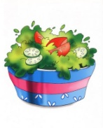](https://www.google.es/url?sa=i&rct=j&q=&esrc=s&frm=1&source=images&cd=&cad=rja&docid=fOuKlEM7c8zHiM&tbnid=8yL6cRWEsRGsxM:&ved=0CAUQjRw&url=https://picasaweb.google.com/107118525942841349319/Alimentos&ei=SYpFUoXvMcKb0wWkz4GYBg&bvm=bv.53217764,d.ZGU&psig=AFQjCNGlPK2yOzG8celmlclG9gVcSp_ZpQ&ust=1380375490534934)[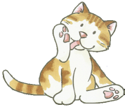](http://www.google.es/url?sa=i&rct=j&q=&esrc=s&frm=1&source=images&cd=&cad=rja&docid=jFn5lwOowQy2aM&tbnid=7BhUik_wCVj_OM:&ved=0CAUQjRw&url=http://www.imagui.com/a/gato-sentado-dibujo-iLLreq77y&ei=yotFUtqSGOGw0QXwpYCIBw&bvm=bv.53217764,d.Yms&psig=AFQjCNEjDeaw7Om4hj4ME6DSmjzM71_6fw&ust=1380375853300969)[](http://www.google.es/url?sa=i&rct=j&q=&esrc=s&frm=1&source=images&cd=&cad=rja&docid=s09-lLRMCLBwJM&tbnid=v54QIaKFIkoucM:&ved=0CAUQjRw&url=http://es.123rf.com/photo_13764349_pastel-de-queso-al-estilo-dibujo.html&ei=r4lFUsOpG4_Z0QXr4YDYBQ&bvm=bv.53217764,d.ZGU&psig=AFQjCNFrjF4kMdj7KuBWlv6NxmZ1sCGVmg&ust=1380375307499982)[](http://www.google.es/url?sa=i&rct=j&q=&esrc=s&frm=1&source=images&cd=&cad=rja&docid=ikRQBKpILWRcbM&tbnid=7QsgRhjIpoJyBM:&ved=0CAUQjRw&url=http://www.istockphoto.com/stock-illustration-11520495-soccer-player.php&ei=6YdFUpTlNanL0QW08YHADg&bvm=bv.53217764,d.ZGU&psig=AFQjCNGTjYfQ6Zliivaj0f6jR6Ac8ka4RQ&ust=1380374820525196)[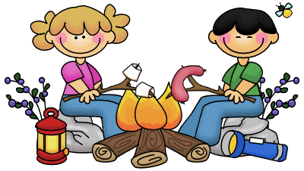](http://www.google.es/url?sa=i&rct=j&q=&esrc=s&frm=1&source=images&cd=&cad=rja&docid=Dxk3GmQDVvkL-M&tbnid=nAJv9YCSNRFHdM:&ved=0CAUQjRw&url=http://www.ecboe.org/site/Default.aspx?PageID=7239&ei=XYVFUp3rLsen0QWr6oH4DA&bvm=bv.53217764,d.ZGU&psig=AFQjCNEiJ2sMcpSZZvl0UpHe-MR4-K0zSg&ust=1380374008625241)[](http://www.google.es/url?sa=i&rct=j&q=&esrc=s&frm=1&source=images&cd=&cad=rja&docid=Mv5Yw1qvFvsnaM&tbnid=MXfq5aeDP7ZCpM:&ved=0CAUQjRw&url=http://www.123rf.com/photo_13603954_fresh-vanilla-ice-cream-cone-in-cartoon-style.html&ei=qIZFUqWlJYiz0QX1l4HQCQ&bvm=bv.53217764,d.ZGU&psig=AFQjCNFeJVKhQC9zv60khLgjvpZDLJ2GjA&ust=1380374558148395)

**Nom: Classe:**

**Pierre n’aime pas le poisson (__ )**

**Pierre aime le football ( __ )**

**Pierre n’aime pas la pizza ( __ )**

**Pierre aime les poires ( __ )**

**Pierre n’aime pas les lapins ( __ )**

**Adèle aime le lait ( __ )**

**Adèle n’aime pas les chats ( __ )**

**Adèle aime les gâteaux (__ )**

**Adèle n’aime pas l’avion ( __ )**

**Adèle aime les biscuits ( __ )**

**Je n’aime pas le, la, les…**

**Je n’aime pas le, la, les …**

**J’aime le, la, les …**

**J’aime le, la, les…**